BIBI FATMA TEACHERS’ TRAINING COLLEGE
Vill. & P.O- Bikrampur Banday, Dist.- Samastipur – 848129
Non- Teaching & Supporting Staff

SI. No. | Name | Designation | Mobile No. | E-mail ID | Photo
1. | SHAKEEL AHMAD | Librarian | 9334521982 | shakee.smp@gmail.com | 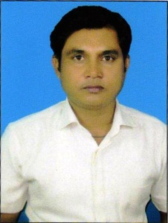
2. | MD. QUAMER JAWAID | Office Assistant Cum – Computer Operator | 9631045610 | qamarjawaidm@gmail.com | 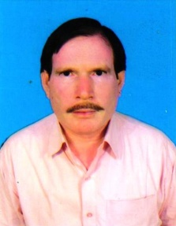
3. | HRISHIKESH KUMAR | Office Cum -Account Assistant | 9661793008 | hrishikeshchy1986@gmail.com | 
4. | MD. MOJAHID | Store Keeper | 7762086540 | mdmojahid33@gmail.com | 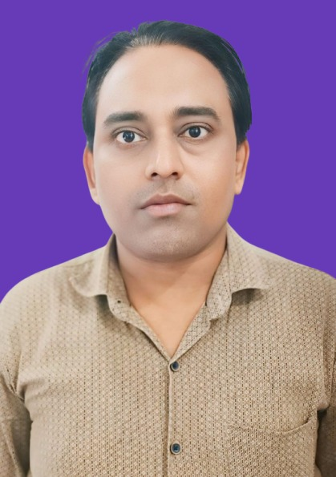
5. | MD. RUBAID ALAM | Technical Assistant | 9709673862 | rubaid3@gmail.com | 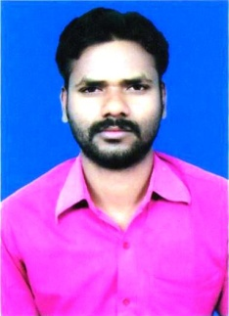
6. | GAUTAM KUMAR CHAUDHARY | Lab Assistant | 8294899376 | gautamkumarchaudhary8294@gmail.com | 
7. | UMESH RAM | Lab Attendant | 8298258996 | ramumesh8298@yahoo.com | 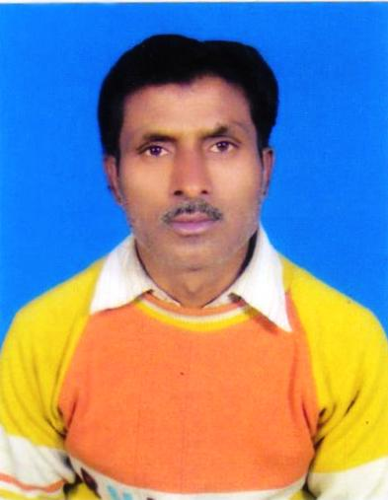
8. | MD. ZAFRUL HODA | Peon | 8877388686 | hodazafrul8877@yahoo.com | 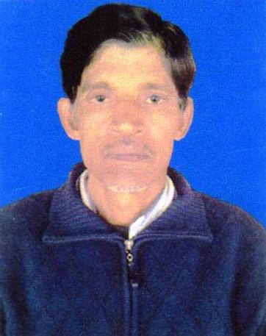
9. | DINESH ROY | Peon | 8084002730 | roydinesh8084@yahoo.com | 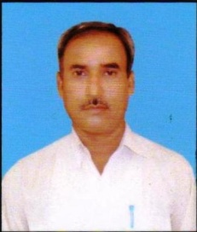
10. | RAGHU KUMAR | Mali | 9931022685 | raghukumarspj1982@gmail.com | 
11. | VIRENDRA RAM | Sweeper | 9708650682 | ramvirendra9708@yahoo.com | 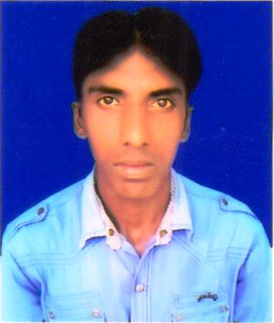
12. | VIDYA PASWAN | Sweeper | 7079868674 | paswanvidya7079@yahoo.com | 