BIBI FATMA TEACHERS’ TRAINING COLLEGE
BIKRAMPUR BANDAY,SAMASTIPUR

LIST OF TECHNICAL SUPPORT STAFF
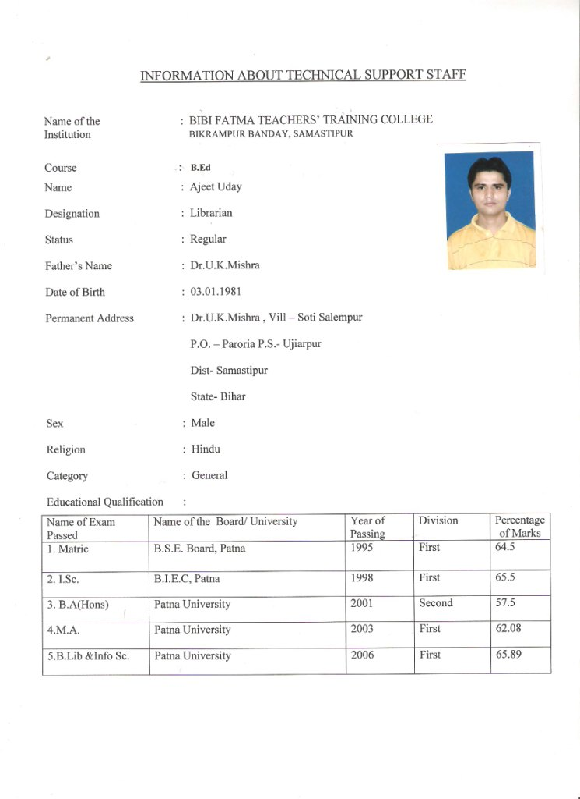

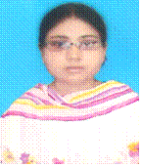

Name of the : BIBI FATMA TEACHERS’ TRAINING COLLEGE
Institution BIKRAMPUR BANDAY, SAMASTIPUR

Course : B.Ed
Name : Sujata Kumari “Lovely”
Designation : Art Education Teacher
Status : Part-Time
Father’s Name : Mankeshwar Prasad Srivastava
Date of Birth : 11-01-1983

Permanent Address : R.N.A.R.College Road
Azad Chowk
Samastipur
Sex : Female
Religion : Hindu
Category : General

Educational Qualification :
Name of Exam  Passed | Name of the Board/  University | Year of Passing | Division | Percentage of Marks
1. Matric | B.S.E. Board, Patna | 1999 | First | 61.00
2. I.Sc. | B.I.E.Council, Patna | 2001 | First | 72.00
3. B.Sc.(Hons) | L.N.M.U. Darbhanga | 2004 | First | 63.00
4. M.Sc.(Zoo) | L.N.M.U. Darbhanga | 2006 | First | 60.00
5. B.F.A | Prachin Kala Kendra, Chandigarh | 2004 | First | 65.00

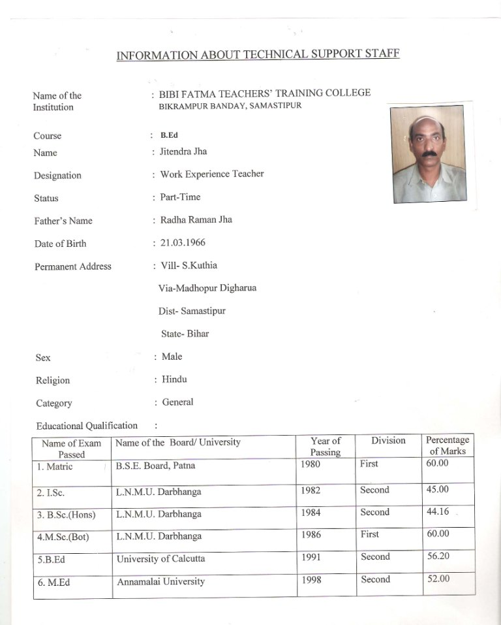

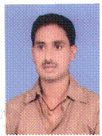
Name of the : BIBI FATMA TEACHERS’ TRAINING COLLEGE
Institution BIKRAMPUR BANDAY, SAMASTIPUR

Course : B.Ed
Name : Sharat Chand Lal
Designation : IT Literacy Teacher
Status : Part-Time
Father’s Name : Manik Chand Lal
Date of Birth : 25-04-1975
Permanent Address : C/o Roy Saheb Lalchand Lal
Station Road
Dist. Samastipur
Sex : Male
Religion : Hindu
Category : SC.

Educational Qualification :
Name of Exam  Passed | Name of the Board/  University | Year of Passing | Division | Percentage of Marks
1. Matric | B.S.E. Board, Patna | 1989 | Second | 54.66
2. I.Sc. | B.I.E.Council, Patna | 1991 | Second | 58.00
3. B.Sc.(Hons) | L.N.M.U. Darbhanga | 1996 | First | 60.25
4. M.C.A. | IGNOU | 2004 | First | 61.78

Name of the : BIBI FATMA TEACHERS’ TRAINING COLLEGE
Institution BIKRAMPUR BANDAY, SAMASTIPUR

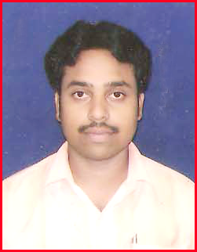
Name : Rajan Kumar
Father’s Name : Mr.Surender Sah
Designation : Physical Education Teacher
Date of Birth : 26.08.1983
Permanent Address : Amgola Road
P.O.:- Ramna
Dist.:-Muzaffarpur
State- Bihar
Sex : Male
Religion : Hindu
Category : B.C.
Status : Part time
Academic Qualification :
Name of Exam Passed | Name of Board /University | Subject Studied | Year of Passing | % of Marks
Matric | Bihar School Exam Board  Patna | Hindi, Eng, Math, S.Sc., N.Sc. | 1998 | 54.29
I.Com. | Bihar Inter Edu. Council ,  Patna | RBH,Eng, BKA & BMO, | 2000 | 65.22
B.Com (Hons) | B.R.A. Bihar University, Muzaffarpur | Account(Hons) EC, PED,.B.O. & M.B. | 2004 | 74.13

Professional Qualification :
B. P.Ed. | Sant Gadge Baba Amravati (Maharashtra) | P.S.F. of Phy.Edu., Edu & Sport Psy. Anatomy | 2009 | 78.53
M. P.Ed. | Pandit Ravi Shankar University , Raipur | Reaserch(Process & Statis)  Exercise & Sports Psycho, Biomechanics | 2010-11 | 72.90

